**Swagat Panda**

**2017B5A30983P**

**Analog Electronics Lab 1 – CE Amplifier**

**Objectives**

**Design the provided circuit on LT Spice and calculate the following parameters with and without the emitter capacitor:**

A. Voltage gain

B. Input Resistance

C. Output Resistance

D. Show input and output waveform

**Components**

* DC Voltage source 15 V
* Resistances of values 6.8 kΩ, 390 Ω, 2.2 kΩ, 3.9 kΩ and 5.6 kΩ
* One variable Resistance
* Capacitors of values 10 μF, 10 μF and 100 μF
* AC voltage source (50mV, 1kHz)

**Determination of the Variable Resistance for the desired Q point**

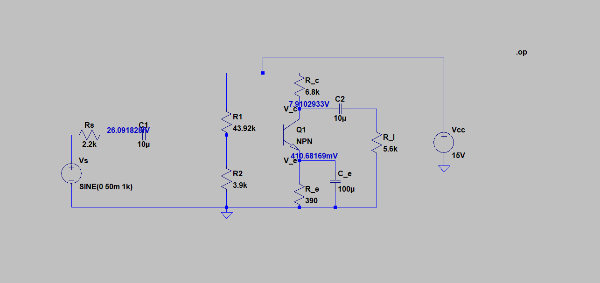

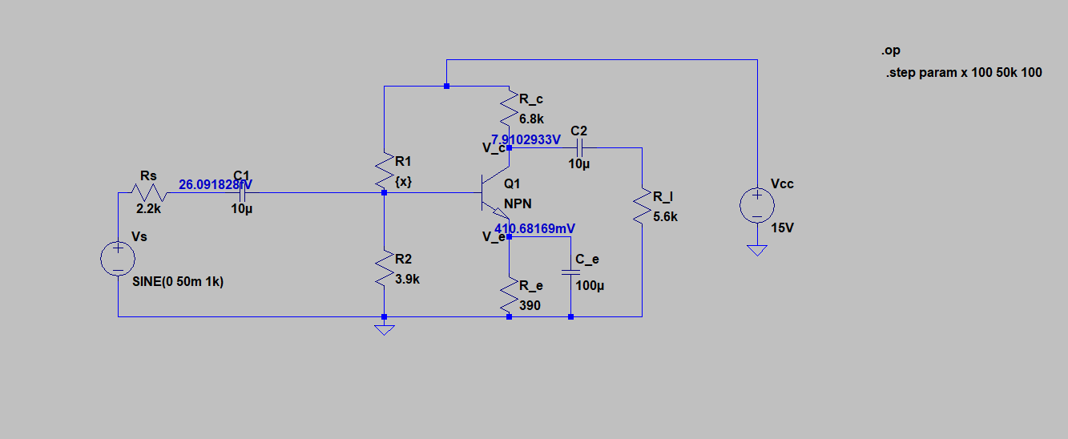

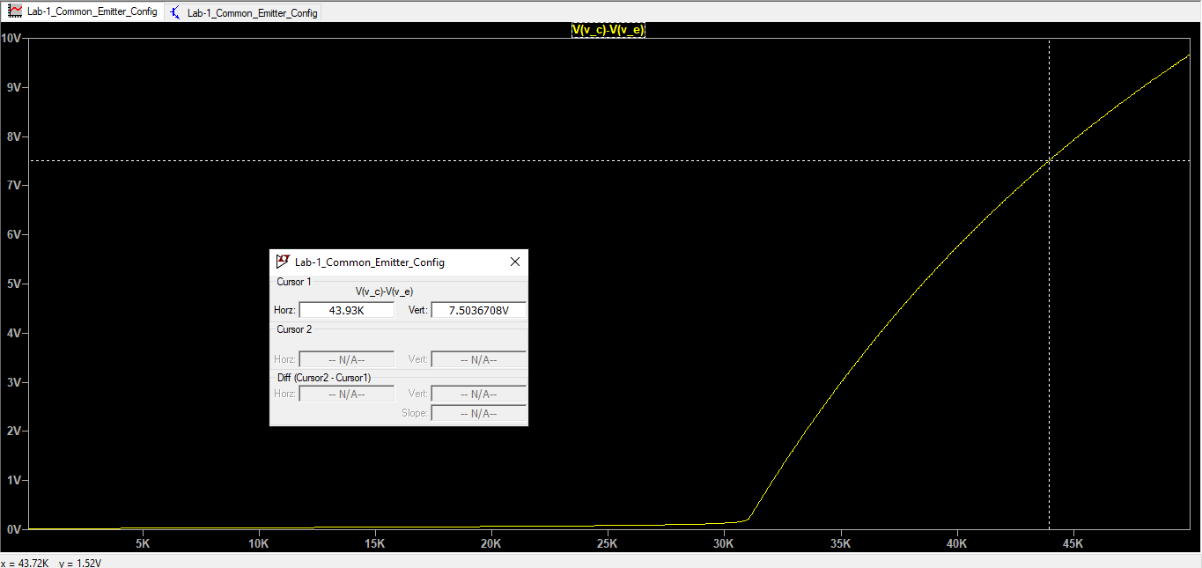

DC Analysis using .op – ${\text{R}}_{\text{1}}$ comes out to be 43.92 k $Ω$, for ${\text{V}}_{\text{CE}}=7.5\text{V}$.

**.ac Analysis to find the gain at 1 kHz**

Gain with ${\text{C}}_{\text{E}}$: – 123.43392

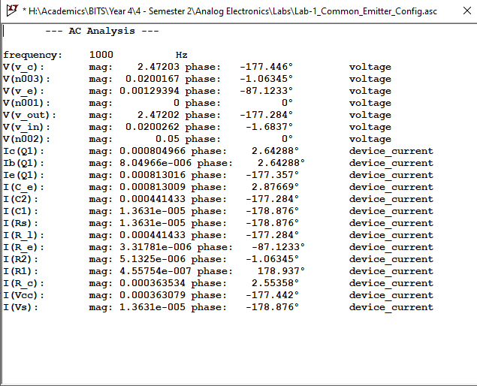

Gain without ${\text{C}}_{\text{E}}$: – 7.334278

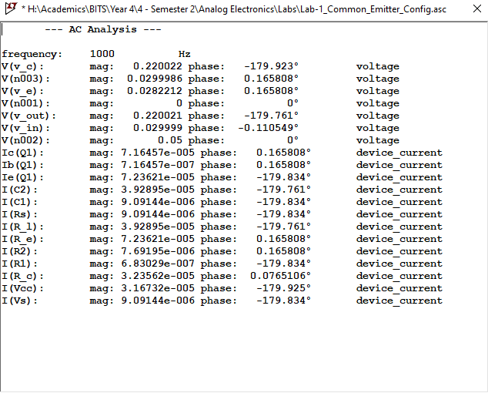

**Input Resistance - ${\text{R}}_{\text{in}}$ with ${\text{C}}_{\text{E}}$**

DC Input Resistance – Infinity

AC Input Resistance:

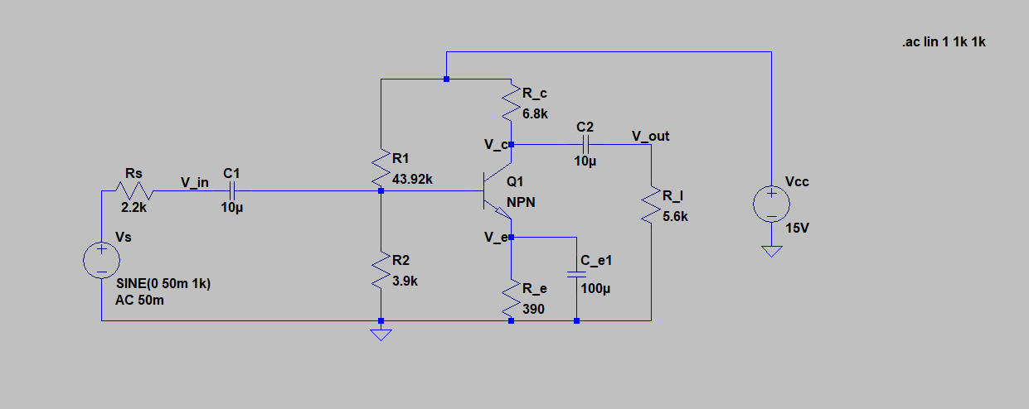



**Input Resistance - ${\text{R}}_{\text{in}}$ without ${\text{C}}_{\text{E}}$**

DC Input Resistance – Infinity

AC Input Resistance:

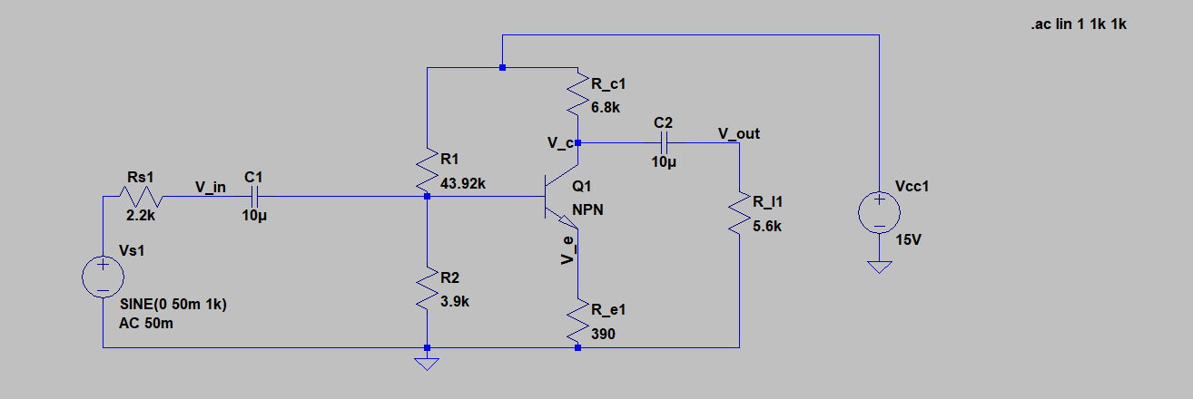

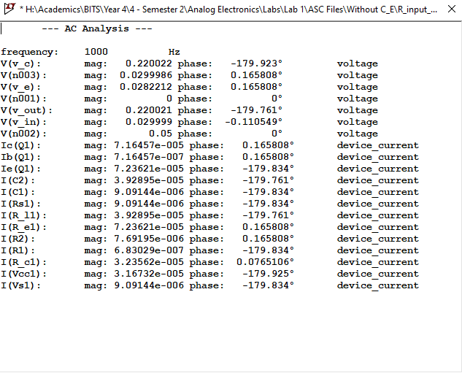

$${\text{R}}_{\text{in}}= \frac{{\text{V}}_{\text{in}}}{{\text{I}}_{\text{in}}}=\frac{0.029999}{9.09144×{10}^{-6}}=3.2997 kΩ$$

**Output Resistance - ${\text{R}}_{\text{out}}$ of the complete circuit (including ${\text{R}}_{\text{L}}$) with ${\text{C}}_{\text{E}}$**

DC Output Resistance – 5.6 $kΩ$

AC Output Resistance:

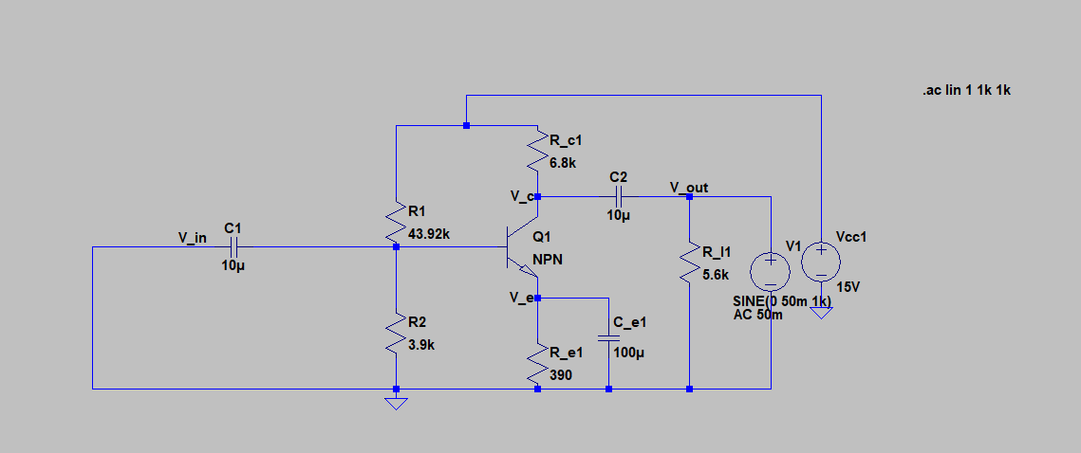

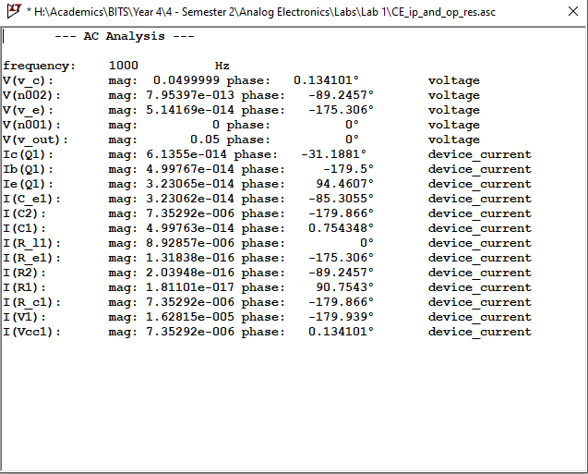

$${\text{R}}_{\text{out with load resistance}}= \frac{{\text{V}}_{\text{out}}}{{\text{I}}_{\text{out}}}=\frac{0.05}{1.62815×{10}^{-5}}={\text{R}}_{\text{c}}||{\text{R}}_{\text{L}}=3.070 kΩ$$

**Output Resistance - ${\text{R}}_{\text{out}}$ of the complete circuit (including ${\text{R}}_{\text{L}}$) without ${\text{C}}_{\text{E}}$**

DC Output Resistance – 5.6 $kΩ$

AC Output Resistance:

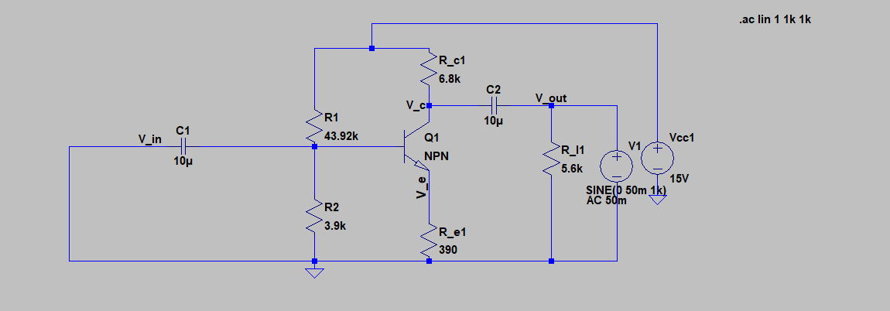



**Output Resistance - ${\text{R}}_{\text{out}}$ of the CE stage only (before ${\text{R}}_{\text{L}}$) with ${\text{C}}_{\text{E}}$**

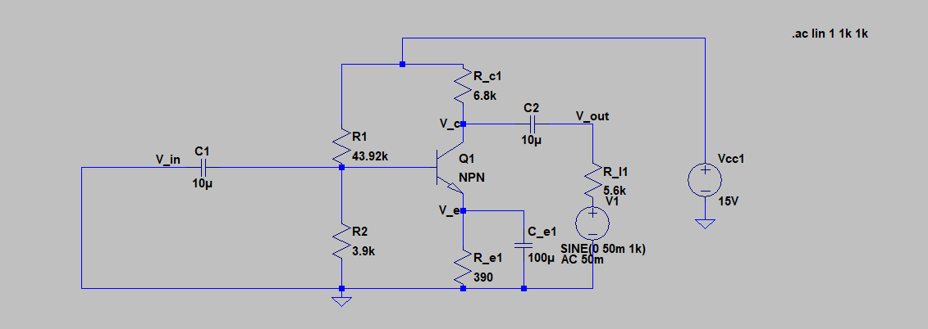

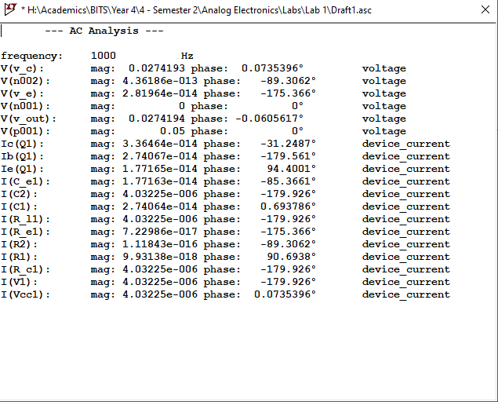

$${\text{R}}_{\text{out of CE stage}}= \frac{{\text{V}}_{\text{out}}}{{\text{I}}_{\text{out}}}=\frac{0.0274194}{4.03225×{10}^{-6}}={\text{R}}_{\text{c}}=6.8 kΩ$$

**Output Resistance - ${\text{R}}_{\text{out}}$ of the CE stage only (before ${\text{R}}_{\text{L}}$) without**

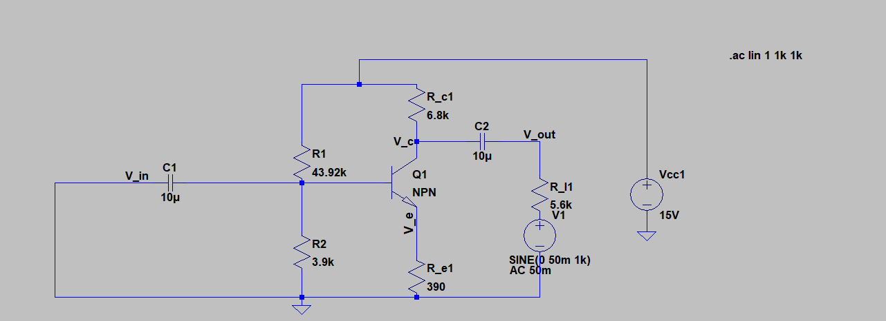



**Input and Output Waveforms**

With ${\text{C}}_{\text{E}}$

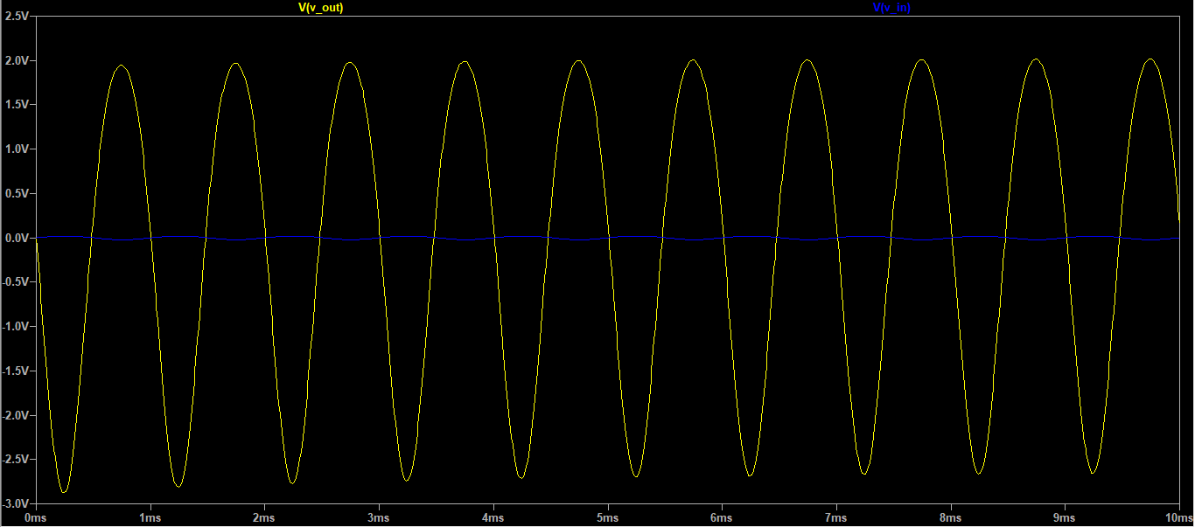

Without ${\text{C}}_{\text{E}}$

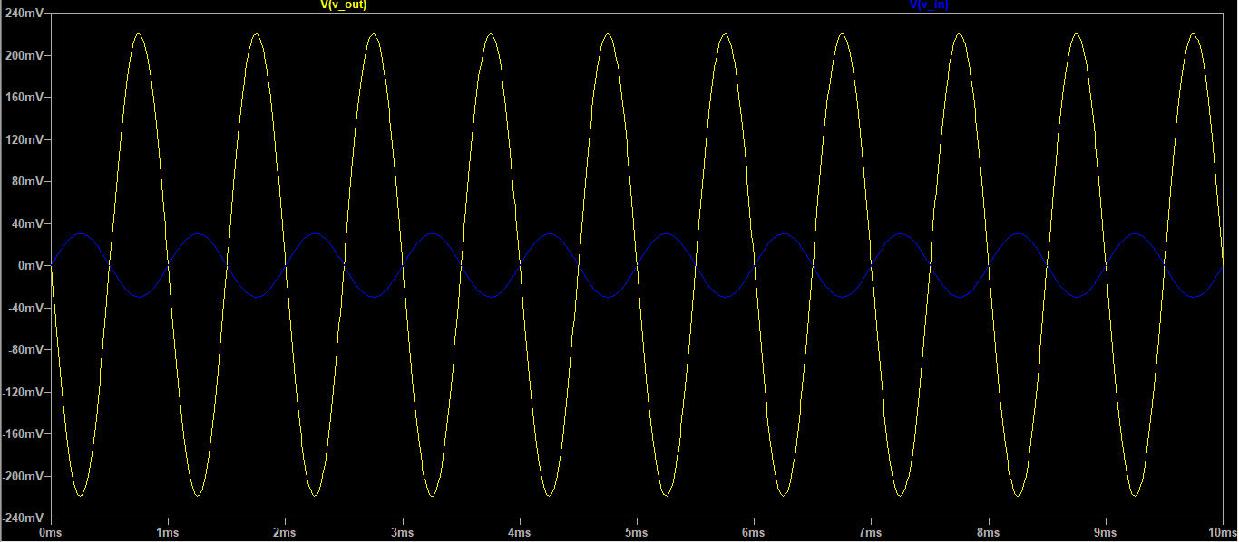

**SPICE Netlist**

Vs N002 0 SINE(0 50m 1k)

R2 Vb 0 3.9k

Re Ve 0 390

C2 Vb Vin 10µ

Rs Vin N002 2.2k

Q1 Vc Vb Ve 0 NPN

R1 N001 Vb 43.92k

Rc N001 Vc 6.8k

Cc1 Vout Vc 10µ

Vcc N001 0 15V

Rl Vout 0 5.6k

C1 Ve 0 100µ

.model NPN NPN

.model PNP PNP

.lib C:\Users\swaga\OneDrive\Documents\LTspiceXVII\lib\cmp\standard.bjt

*.step param 40k 55k 0.1k

*.op

*.ac dec 1 1k 1k

*.tran 10m

.backanno

.end

**Observations & Conclusions:**

* Common emitter circuit uses “Voltage Divider Biasing”, hence bias at V supply /2, at the Q-point. It gives the best stability.
* BJT in CE configuration, behaves as an inverting amplifier.